# SQL Lesson 1

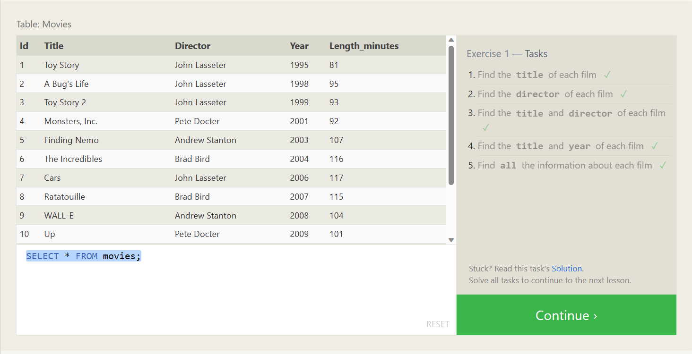

1.SELECT title FROM movies;

2. SELECT director FROM movies;

3. SELECT title,director FROM movies;

4. SELECT title,year FROM movies;

5. SELECT * FROM movies;

# SQL Lesson 2

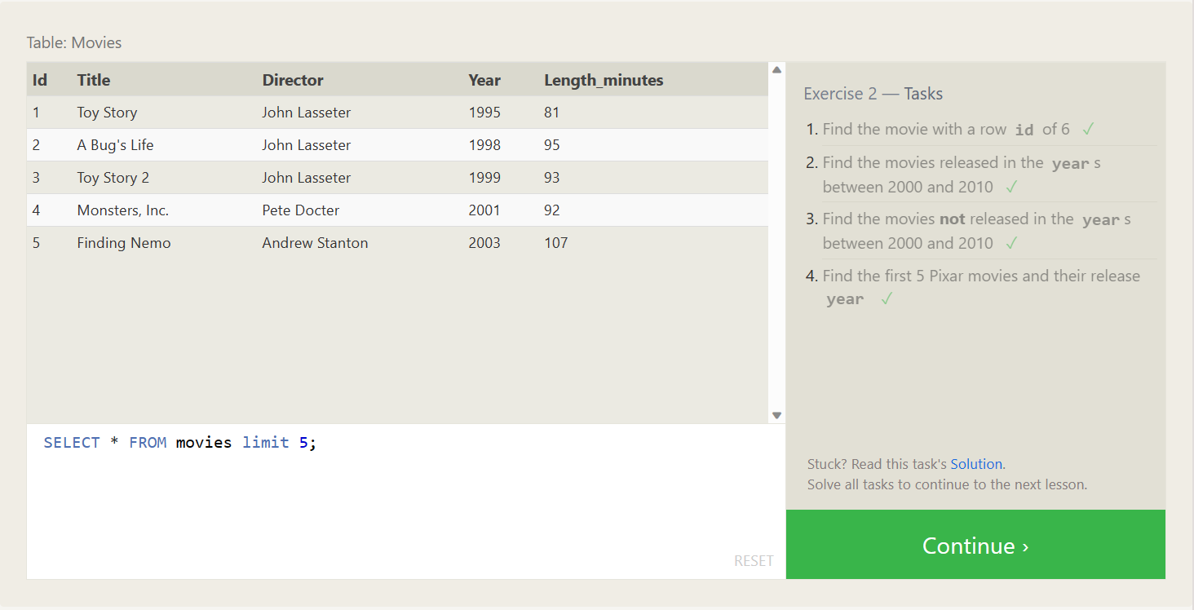

1. SELECT * FROM movies where id = 6;
2. SELECT * FROM movies where year between 2000 and 2010;
3. SELECT * FROM movies where not year between 2000 and 2010;
4. SELECT * FROM movies limit 5;

# SQL Lesson 3

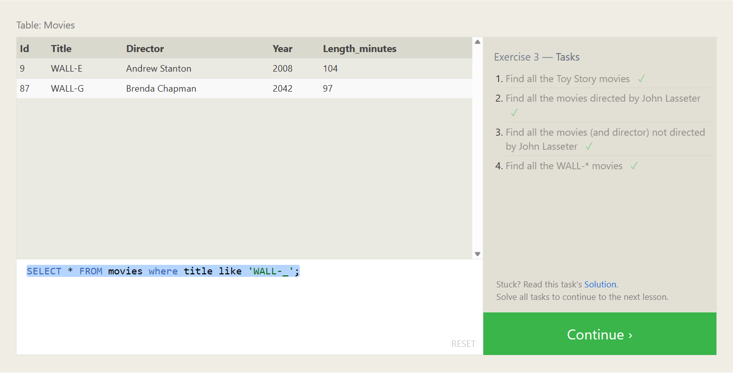

1. SELECT * FROM movies where title like 'toy story%';
2. SELECT * FROM movies where director like 'John Lasseter';
3. SELECT * FROM movies where not director like 'John Lasseter';
4. SELECT * FROM movies where title like 'WALL-_';

# SQL Lesson 4

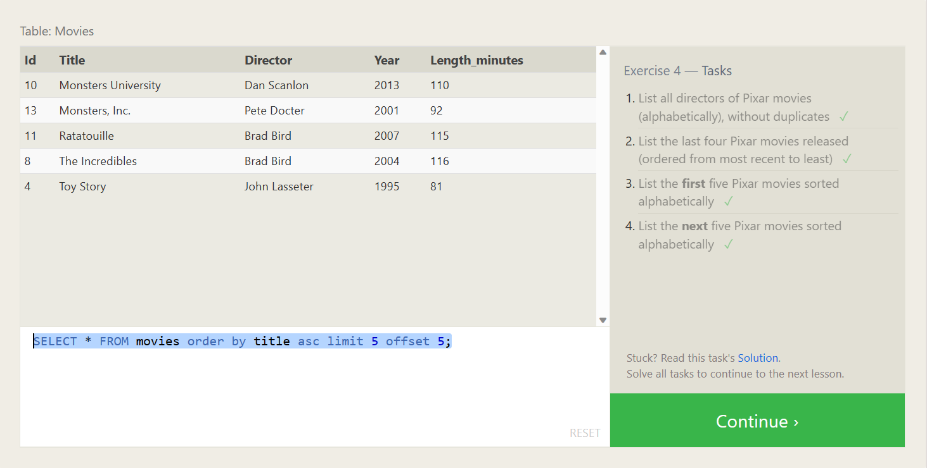

1. SELECT distinct director FROM movies order by director;
2. SELECT * FROM movies order by year desc limit 4;
3. SELECT * FROM movies order by title asc limit 5;
4. SELECT * FROM movies order by title asc limit 5 offset 5;

# SQL Review: Simple Select Queries

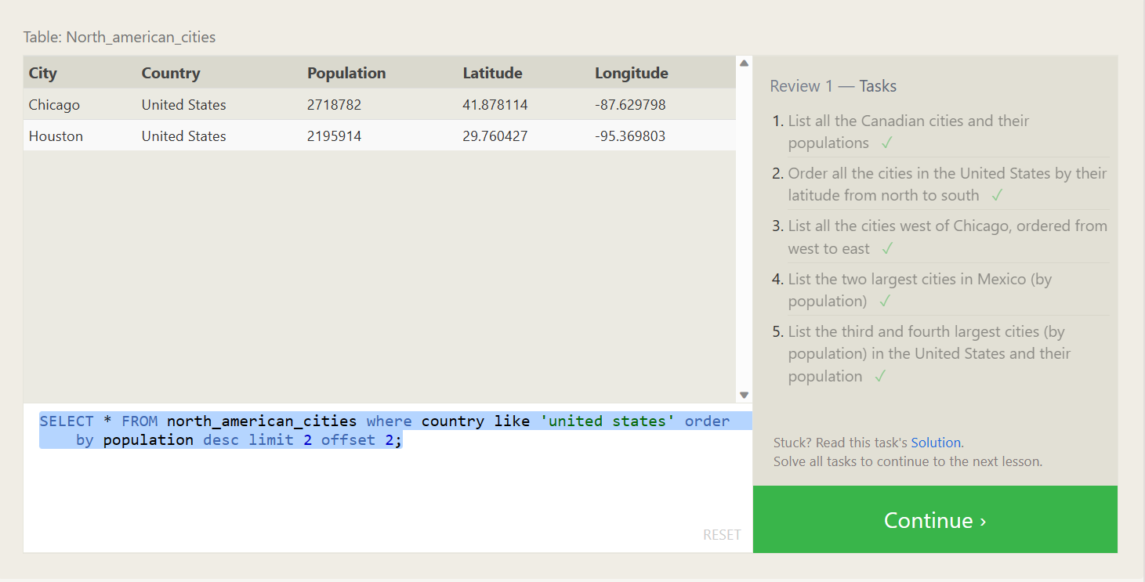

1. SELECT * FROM north_american_cities where country like 'canada';
2. SELECT * FROM north_american_cities where country like 'united states' order by latitude desc;
3. SELECT * FROM North_american_cities where Longitude < -87.69 order by Longitude asc;
4. SELECT * FROM north_american_cities where country like 'mexico' order by population desc limit 2;
5. SELECT * FROM north_american_cities where country like 'united states' order by population desc limit 2 offset 2;

# SQL Lesson 6

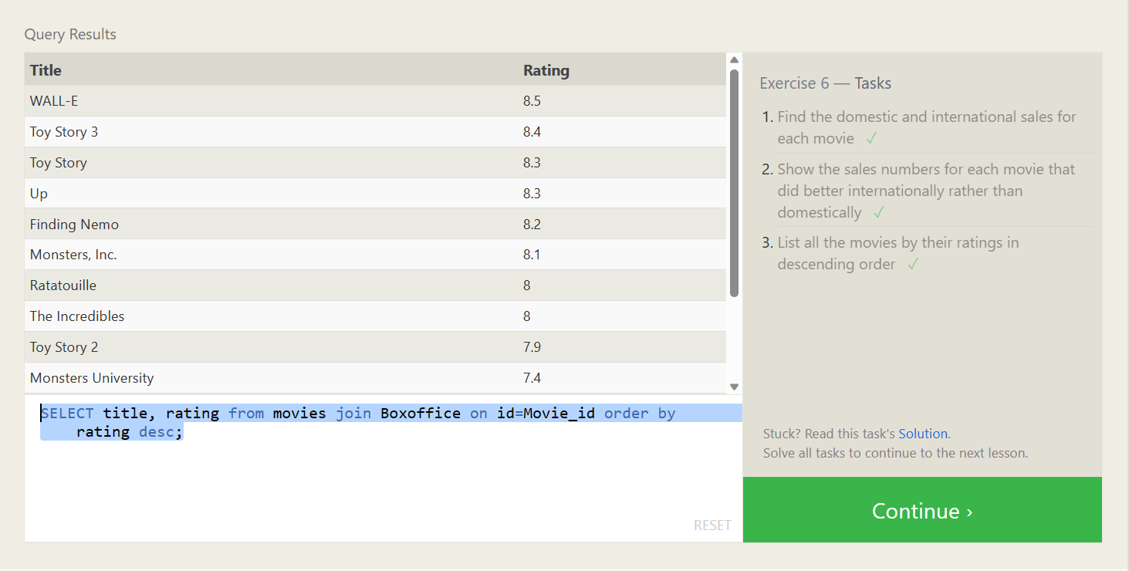

1. SELECT title, international_sales, domestic_sales from movies join

Boxoffice on id=Movie_id;

2. SELECT title, international_sales, domestic_sales from movies join

Boxoffice on id=Movie_id where international_sales > domestic_sales

3. SELECT title, rating from movies join Boxoffice on id=Movie_id order by rating desc;

# SQL Lesson 7

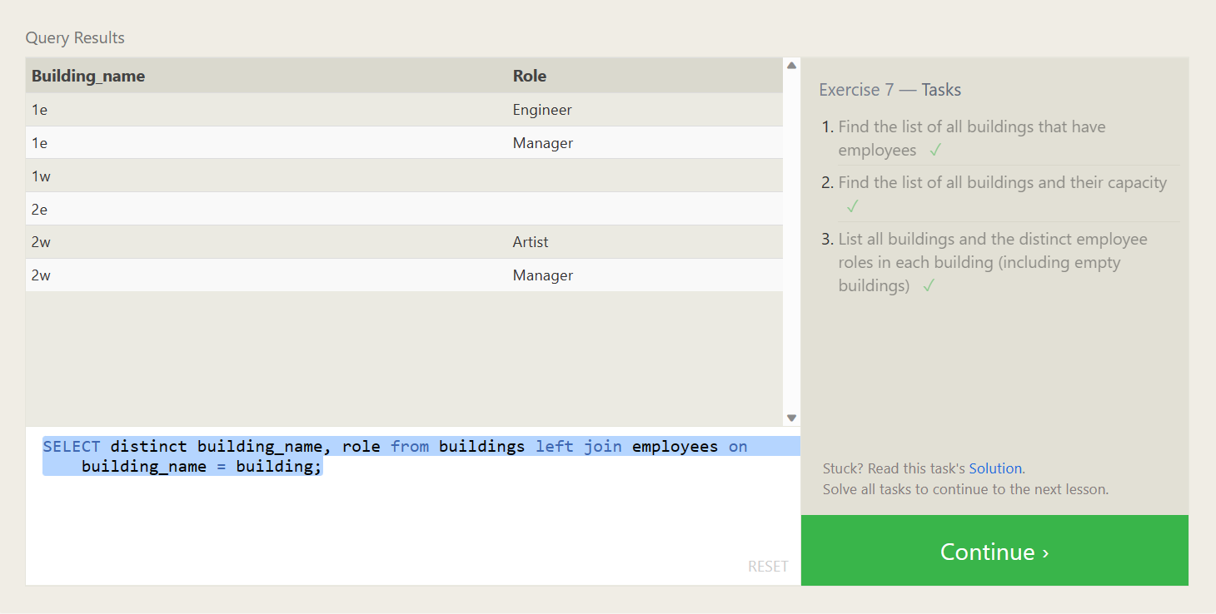

1. SELECT distinct building FROM employees left join buildings on building=building_name where Years_employed not null;
2. SELECT * FROM buildings;
3. SELECT distinct building_name, role from buildings left join employees on building_name = building;

# SQL Lesson 8

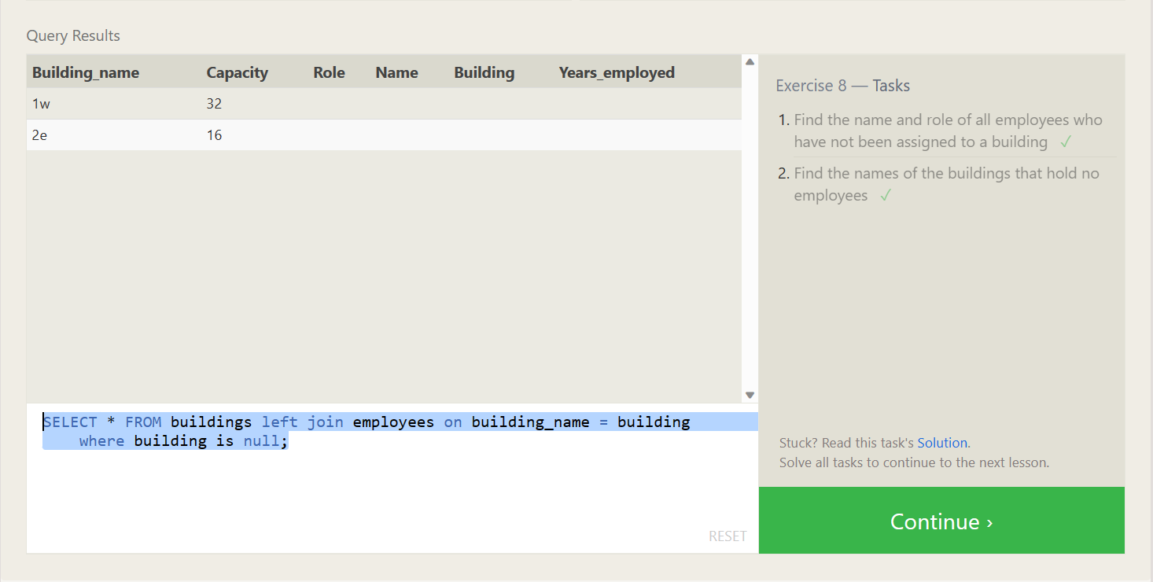

1. SELECT * FROM employees left join buildings on building_name = building where building is null;
2. SELECT * FROM buildings left join employees on building_name = building where building is null;

# SQL Lesson 9

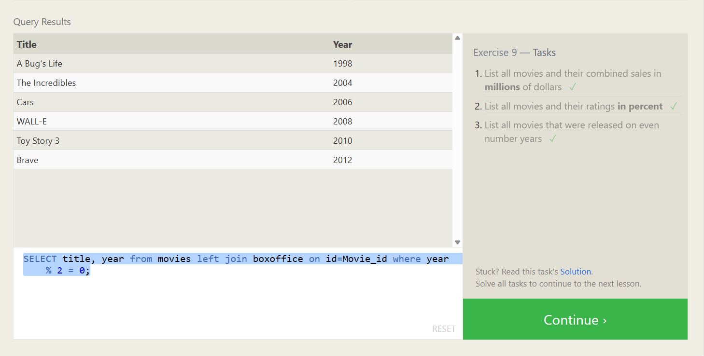

1. SELECT title, (domestic_sales+international_sales)/1000000 as total_sales_millions from movies left join boxoffice on id=movie_id;
2. SELECT title, rating*10 as percent from movies left join boxoffice on Id = movie_id;
3. SELECT title, year from movies left join boxoffice on id = movie_id where year % 2 = 0;

# SQL Lesson 10

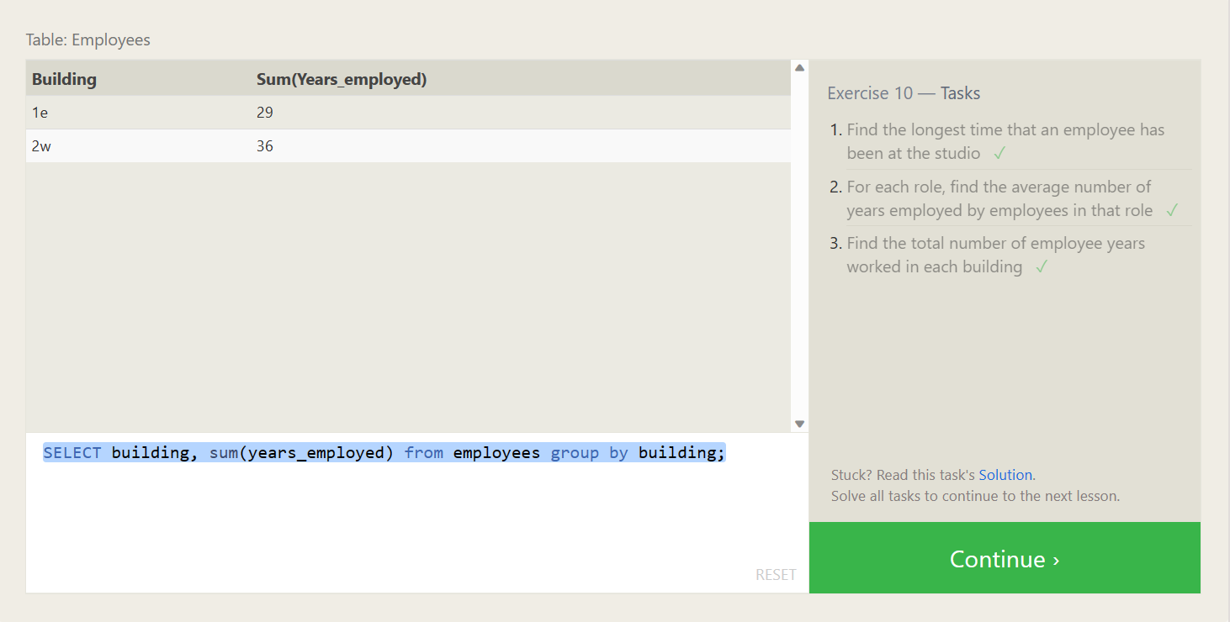

1. SELECT max(years_employed) from employees;
2. SELECT role, avg(years_employed) from employees group by role;
3. SELECT building, sum(years_employed) from employees group by building;

# SQL Lesson 11

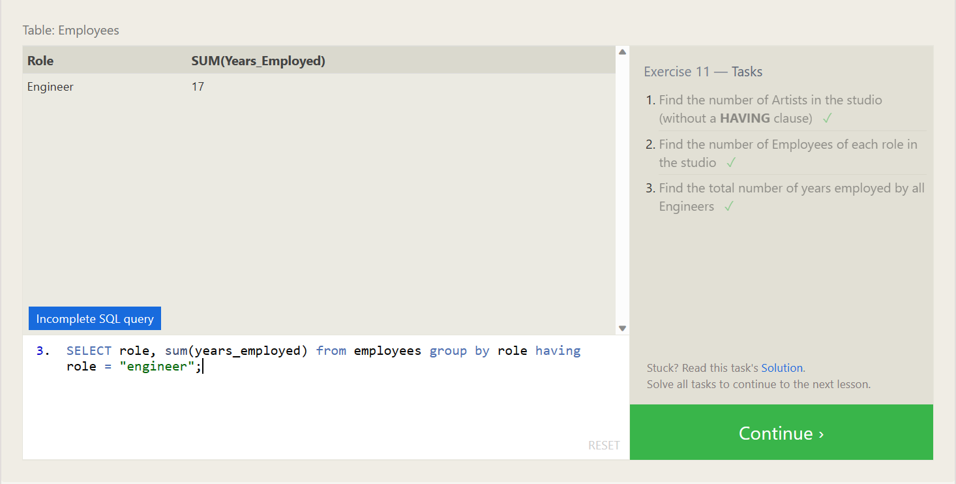

1. SELECT role, count(*) as number_of_artists from employees where role = "artist";
2. SELECT role, count(*) from employees group by role;
3. SELECT Role, SUM(Years_Employed) FROM Employees GROUP BY Role HAVING Role = "Engineer";

# SQL Lesson 12

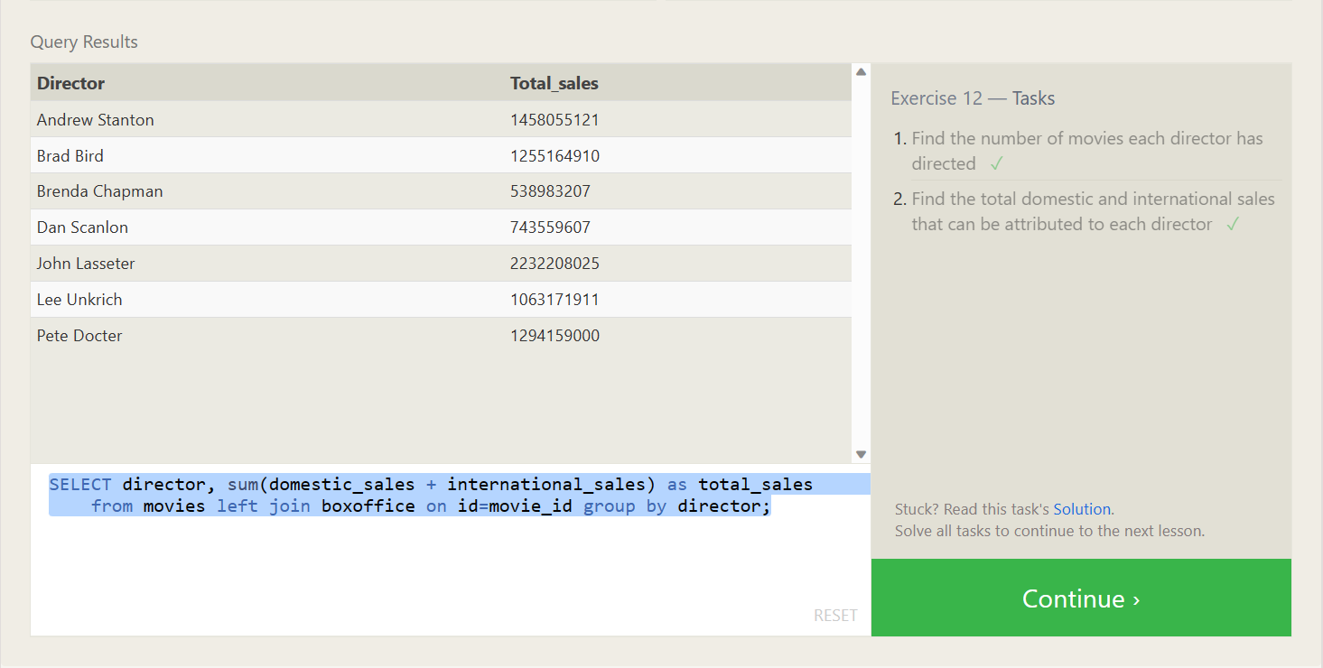

1. SELECT *, count(title) from movies group by directors;
2. SELECT director, sum(domestic_sales + international_sales) as total_sales from movies left join boxoffice on id=movie_id group by director;

# SQL Lesson 13

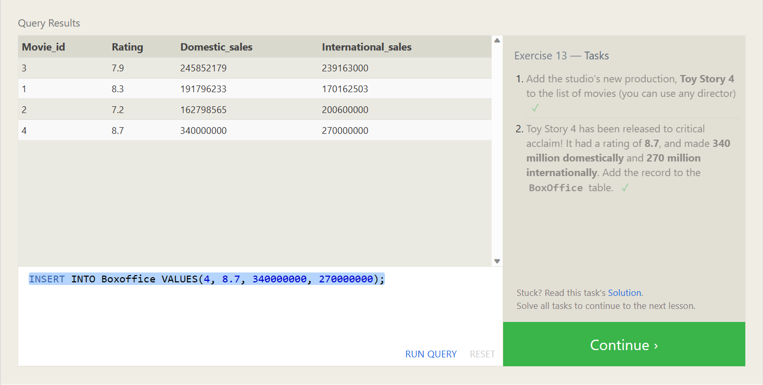

1. INSERT INTO Movies VALUES(4, "Toy Story 4", "John Lasseter", 2017, 123);
2. INSERT INTO Boxoffice VALUES(4, 8.7, 340000000, 270000000);

# SQL Lesson 14

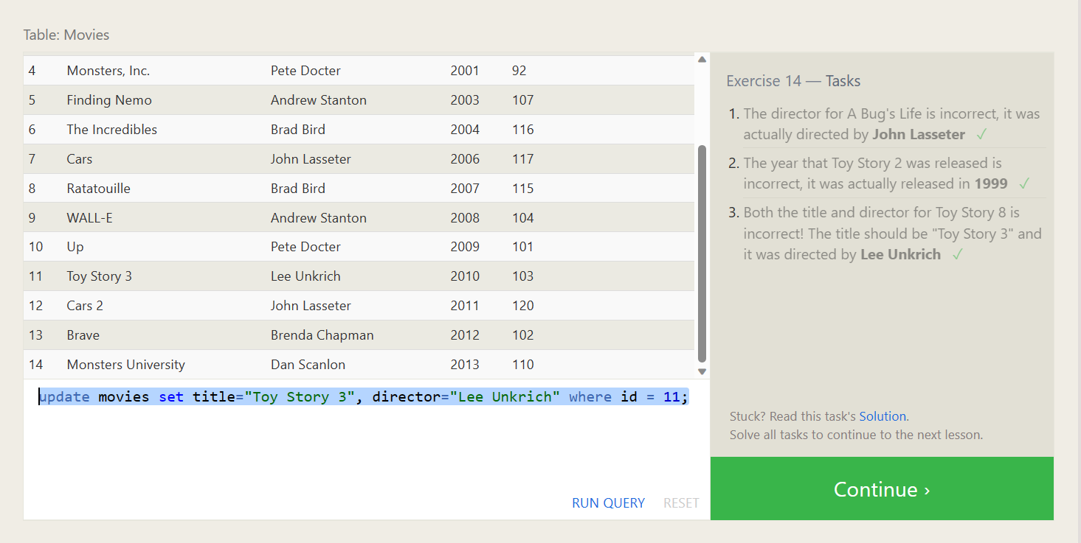

1. update movies set director="John Lasseter" where id = 2;
2. update movies set year=1999 where id = 3;
3. update movies set title="Toy Story 3", director="Lee Unkrich" where id = 11;

# SQL Lesson 15

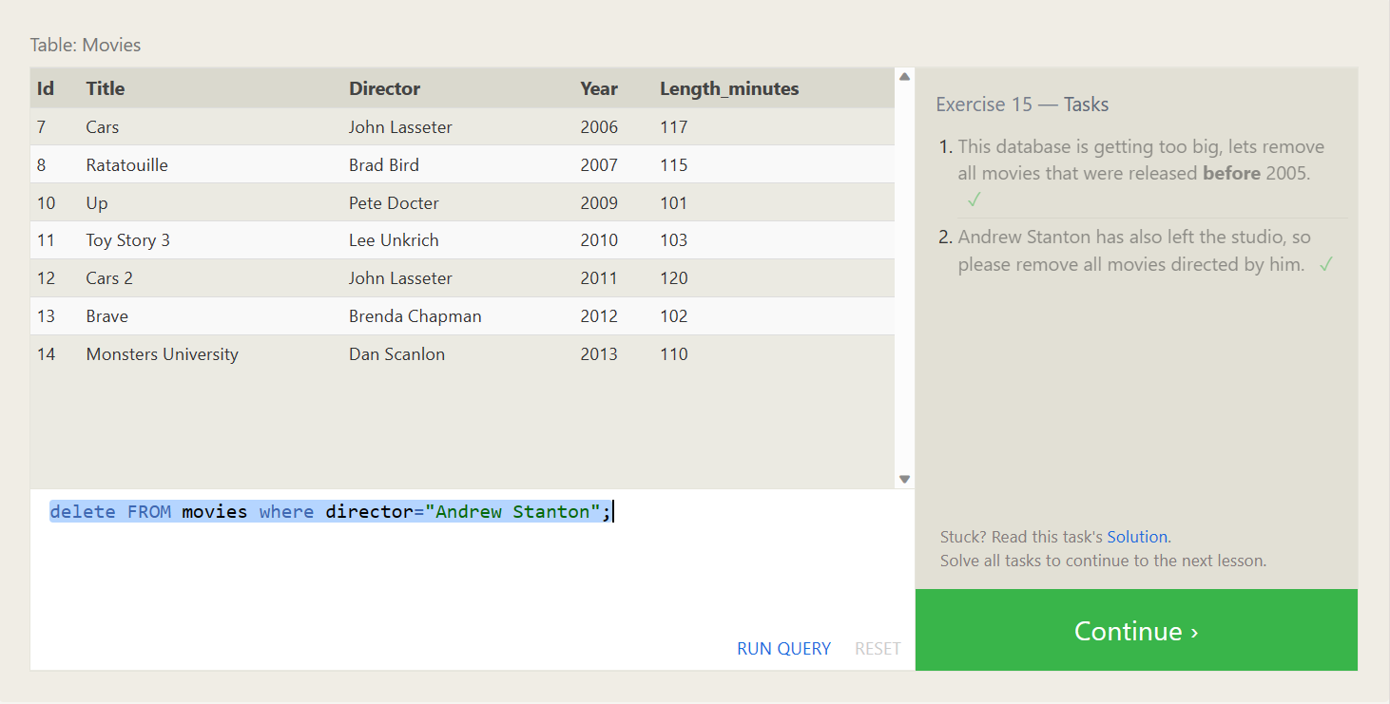

1. delete FROM movies where year < 2005;
2. delete FROM movies where director="Andrew Stanton";

# SQL Lesson 16

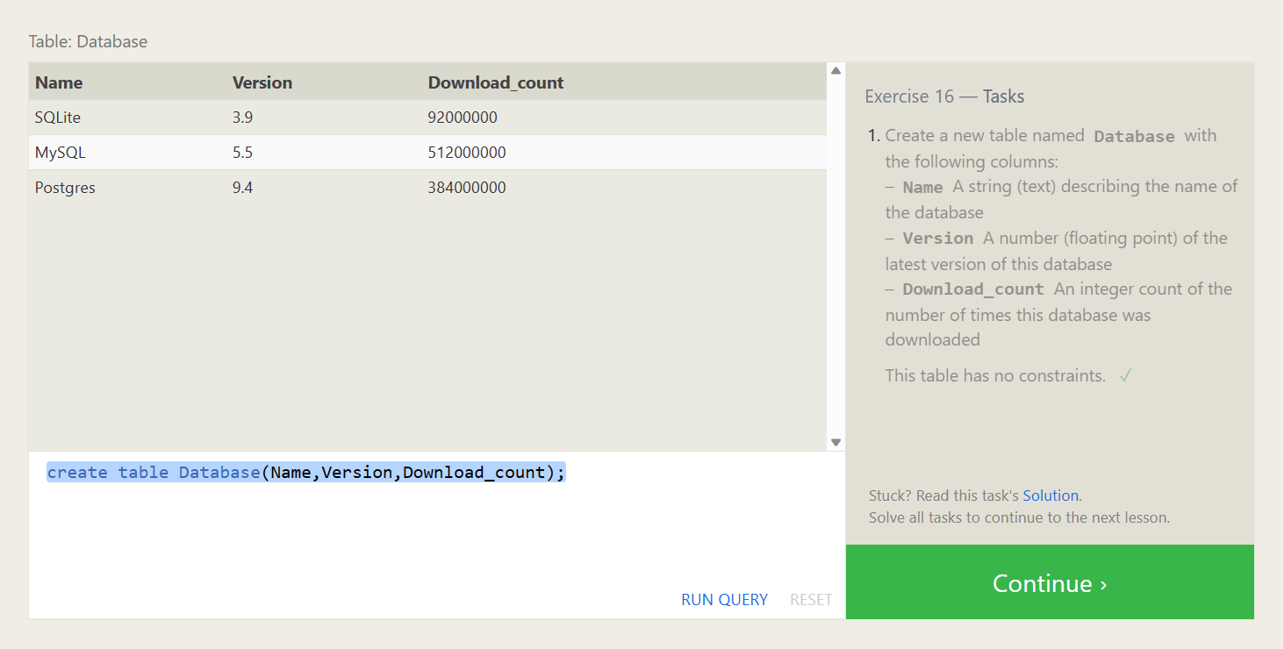

1. create table Database(Name,Version,Download_count);

# SQL Lesson 17

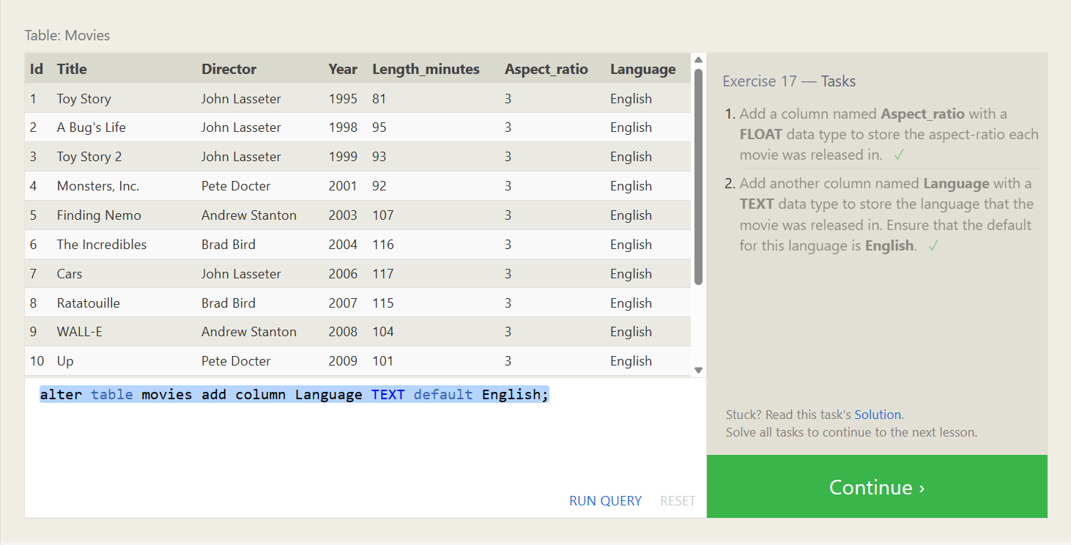

1. alter table movies add column Aspect_ratio FLOAT default 3;
2. alter table movies add column Language TEXT default English;

# SQL Lesson 18

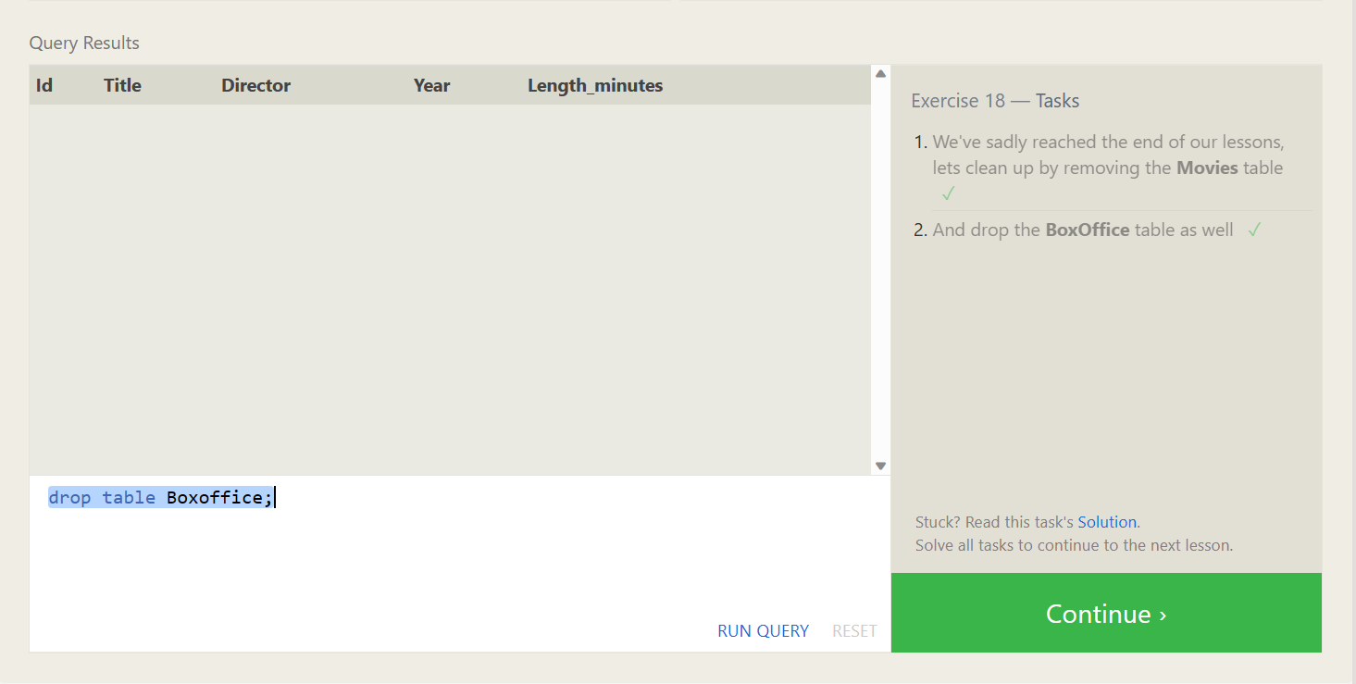

1. drop table movies;
2. drop table Boxoffice;